Insert School Logo

Semester One Examination 2019

Question/Answer Booklet

MATHEMATICS SPECIALIST
UNIT 3

Section Two:
Calculator-assumed

Student Name: _____________________________________

Teacher’s Name: _____________________________________

Time allowed for this section
Reading time before commencing work: ten minutes
Working time for paper: one hundred minutes

Material required/recommended for this section

To be provided by the supervisor
This Question/Answer booklet
Formula Sheet (retained from Section One)

To be provided by the candidate
Standard items: pens(blue/black preferred), pencils(including coloured), sharpener, correction tape/fluid, erasers, ruler, highlighters

Special Items: drawing instruments, templates, notes on two unfolded sheets of A4 paper, and up to three calculators approved for use in the WACE examinations.

Important note to candidates
No other items may be taken into the examination room. It is your responsibility to ensure that you do not have any unauthorised notes or other items of a non-personal nature in the examination room. If you have any unauthorised material with you, hand it to the supervisor before reading any further.

Structure of this paper

 | Number of questions available | Number of questions to be attempted | Suggested working time (minutes) | Marks available | Weighting
Section One  Calculator—free | 6 | 6 | 50 minutes | 53 | 35%
Section Two  Calculator—assumed | 10 | 10 | 100 minutes | 97 | 65%
 |  |  |  | 150 | 100%

Instructions to candidates

- The rules for the conduct of Western Australian external examinations are detailed in the Year 12 Information Handbook 2019. Sitting this examination implies that you agree to abide by these rules.

- Answer the questions according to the following instructions.

Section Two: Write answers in this Question/Answer Booklet. Answer all questions.

Show all your working clearly. Your working should be in sufficient detail to allow your
answers to be checked readily and for marks to be awarded for reasoning. Incorrect
answers given without supporting reasoning cannot be allocated any marks. For any
question or part question worth more than two marks, valid working or justification is required to receive full marks. If you repeat an answer to any question, ensure that you cancel the answer you do not wish to have marked.

It is recommended that you do not use pencil, except in diagrams.

- You must be careful to confine your responses to the specific questions asked and to follow any instructions that are specific to a particular question.

- Spare pages are included at the end of this booklet. They can be used for planning your responses and/or as additional space if required to continue an answer.
- Planning: If you use the spare pages for planning, indicate this clearly at the top of the page.
- Continuing an answer: If you need to use the space to continue an answer, indicate in the original answer space where the answer is continued, i.e. give the page number. Fill in the number of the question that you are continuing to answer at the top of the page.

- The Formula Sheet is not handed in with your Question/Answer Booklet.

Section Two: Calculator–assumed 97 marks

This section has ten (10) questions. Attempt all questions.
Write your answers in the spaces provided.

Working time: 100 minutes

Question 7 (4 marks)

The complex number $z$ is such that $\left|z\right|=4$. Use this information to evaluate the expression below.

$${\left|z+2i\right|}^{2}+{\left|z-2i\right|}^{2}$$
(4 marks)

Question 8 (10 marks)

(a) Points A, B and C have position vectors $〈5, y, -4〉, 〈9, 0, -2〉$ and $〈x, 3, 1〉$ respectively.
Determine the value(s) of x and y so that:

(i) $\vec{OA}+3\vec{OC}$ is a unit vector. (2 marks)

(ii) B divides the line segment AC in the ratio 2 : 3. (4 marks)

(Question 8 – Continued)

(b) Triangle ABC has its vertices at $\vec{OA}=3i-2j+k$, $\vec{OB}=3i+4j+k$ and
$\vec{OC}=-i+j+αk$, where $α∈R$. Determine the value(s) of $α$ so that ΔABC is equilateral.
(4 marks)

Question 9 (10 marks)

(a) State the conditions on the complex number $z=a+bi$ that describe the region given below.
(3 marks)

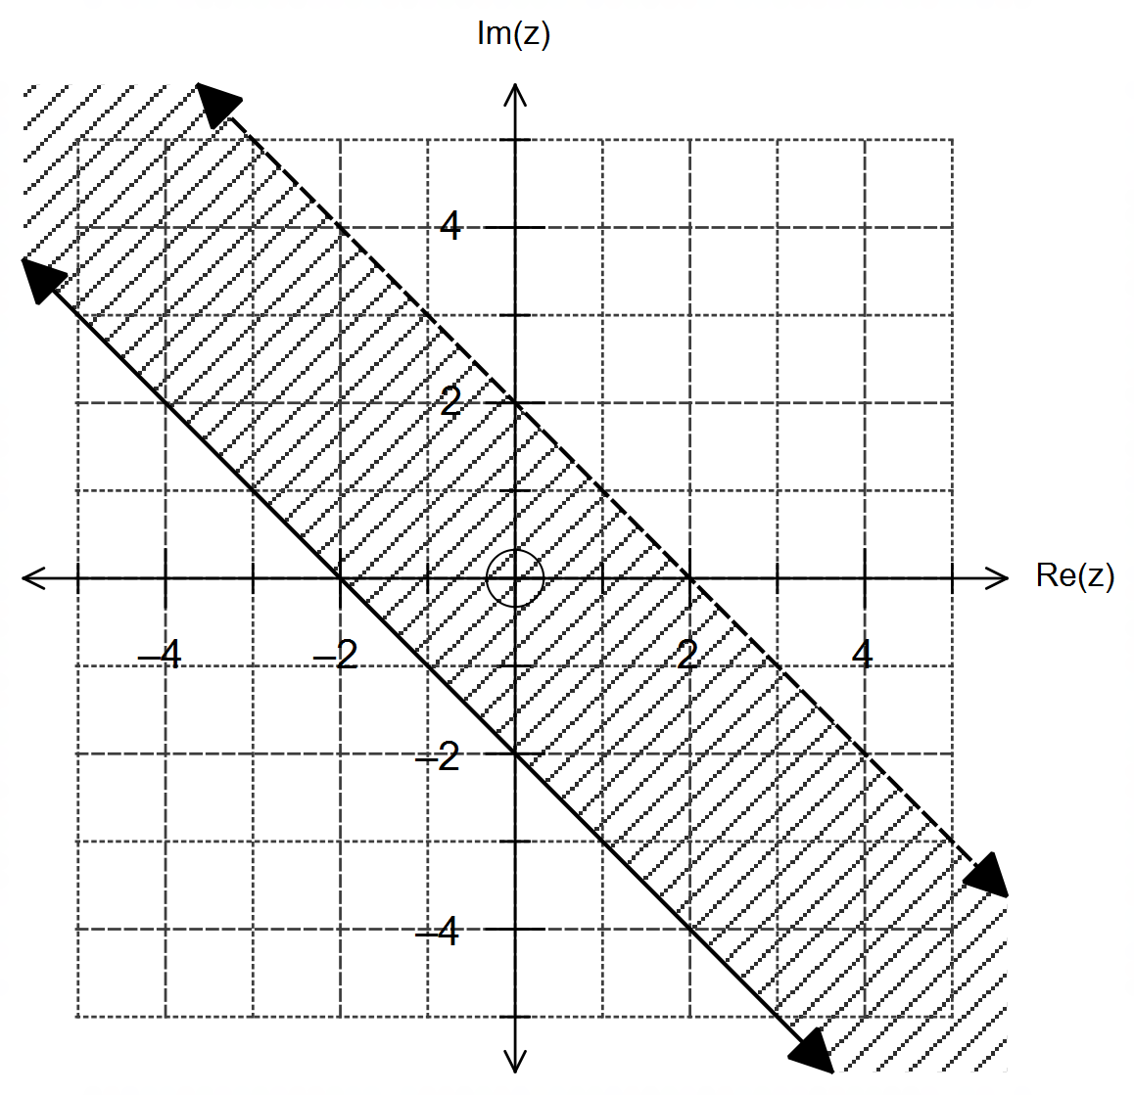

(b) State the conditions on the complex number $z=r\operatorname{cis}{θ}$ that describe the region given below,
where $r≥0$ and $-π<θ≤π$.
(3 marks)

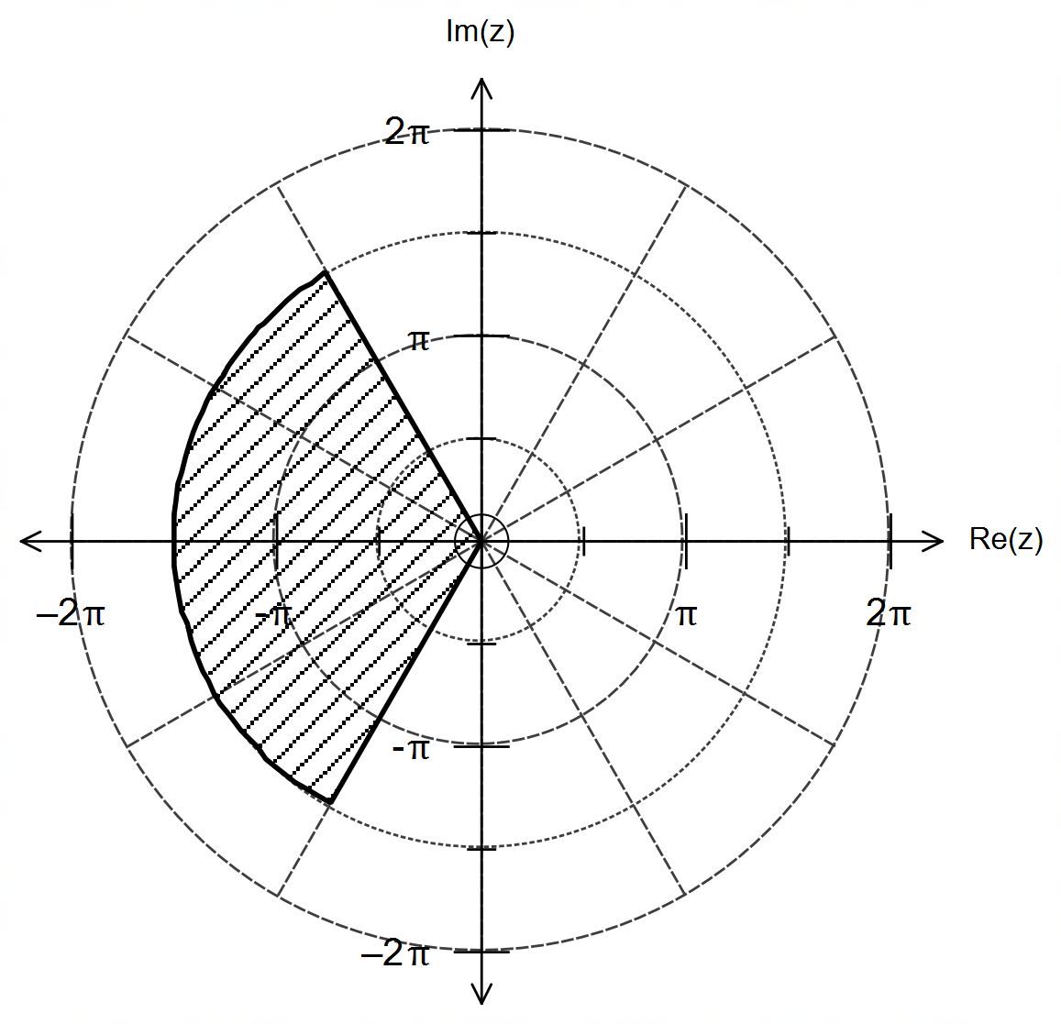

(Question 9 – Continued)

(c) Sketch the following set of complex numbers $z$ in the Argand plane that satisfy the condition:

$$z^{2}+{\overline{z}}^{2}=0$$

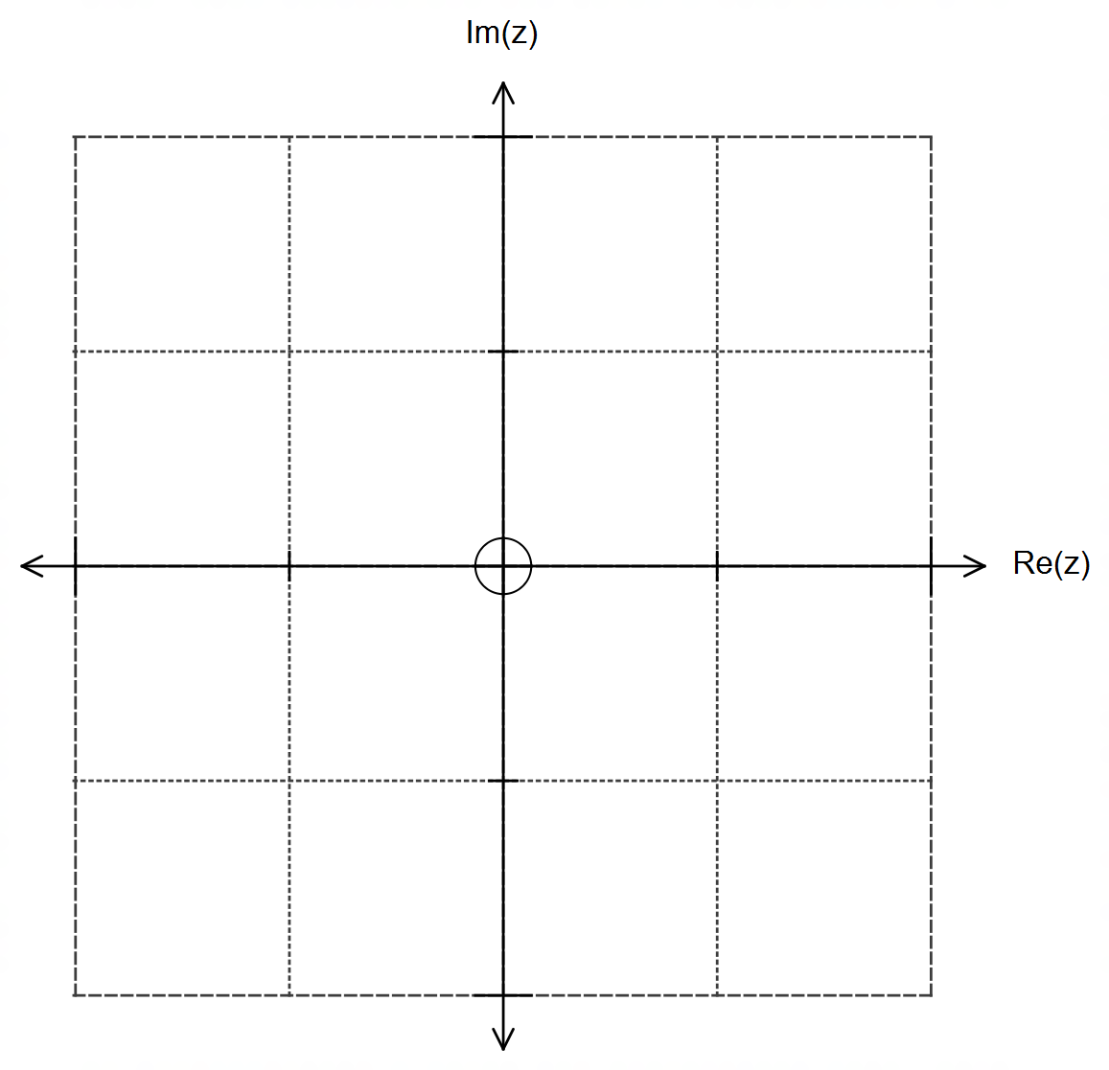

Justify your answer with your working on the space below. (4 marks)

Question 10 (17 marks)

The path traced by the needle of an industrial welding machine is shown on the diagram below.
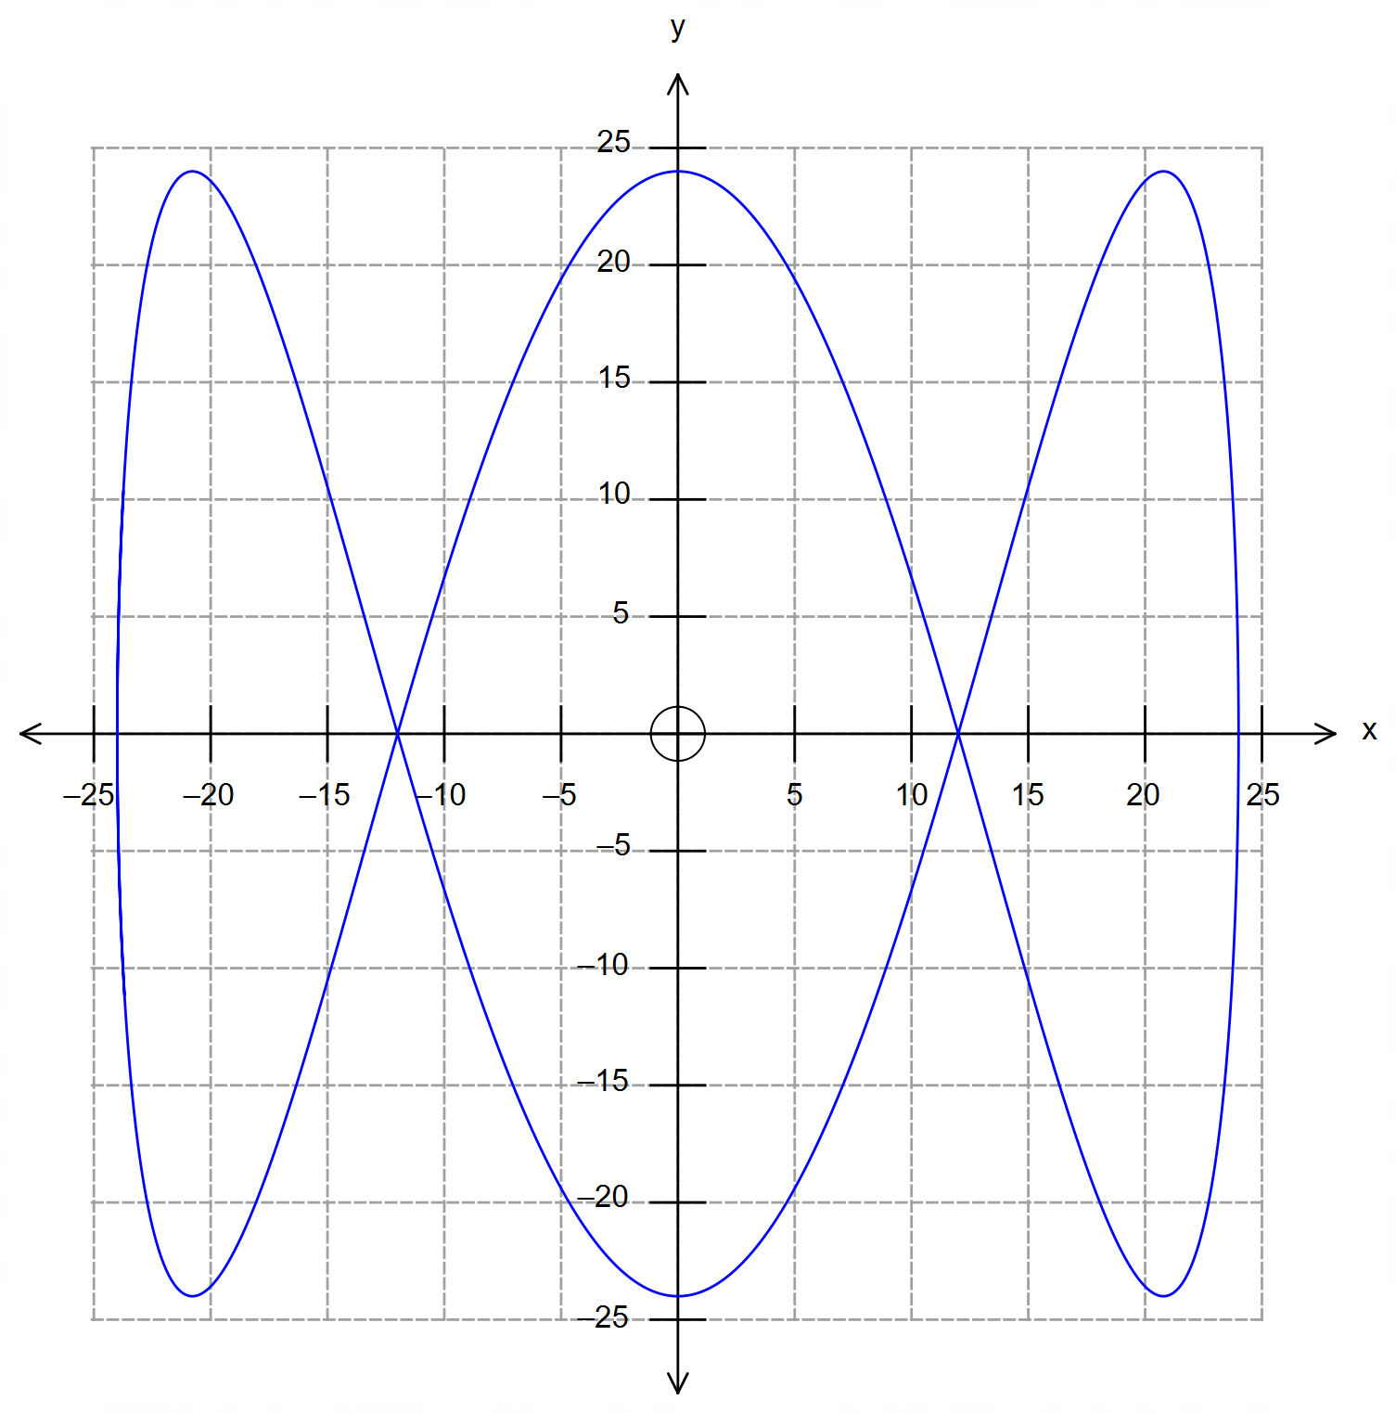

The position of the needle at any time $t$ is given by:

$$r=24\cos\left(\frac{πt}{12}\right)i+24\sin\left(\frac{πt}{4}\right)j$$

where $\left|r\right|$ is in cm, $t$ in seconds, $i$ is a unit vector pointing East and $j$ is a unit vector pointing North.

(a) Find the velocity $v$ of the needle at time $t$. (2 marks)

(Question 10 – Continued)

(b) Determine the position and velocity vectors of the needle at times $t=2$ and $t=6$, and
draw these on the diagram given. Label your answers clearly. (6 marks)

(c) How long does it take for the needle to complete one full cycle? (1 mark)

(d) Find the acceleration of the needle at time $t=8$. (2 marks)

(Question 10 – Continued)

(e) Determine the speed of the needle as a function of $t$. (2 marks)

(f) Use your calculator to determine the maximum speed of the needle and the location
where this first occurs. Clearly indicate this on the same graph. (4 marks)

Question 11 (8 marks)

The grid below shows the graph of $f\left(x\right)$ for the domain $-6≤x≤8$.
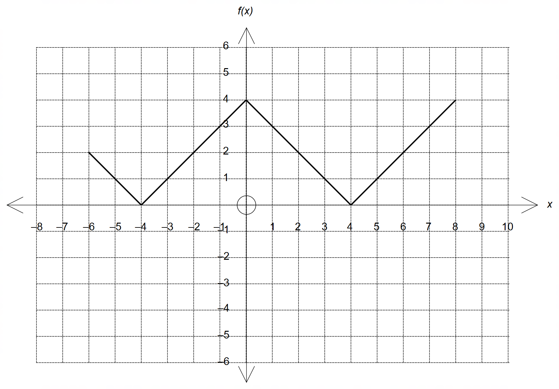

(a) State the equation of $f\left(x\right)$. (2 marks)

(b) The function $g\left(x\right)=-\left|x+a\right|+b$ intersects $f(x)$ for $-4≤x≤-2$.
Determine the value of the constants $a$ and $b$. (2 marks)

(c) State the independent conditions on the positive constants $m$ and $n$ so that the graph
of $h\left(x\right)=m\left|x\right|+n$ intersects the graph of $f\left(x\right)$ exactly four times. (4 marks)

Question 12 (12 marks)

(a) The complex numbers $v$ and $w$ are shown on the polar grid below.
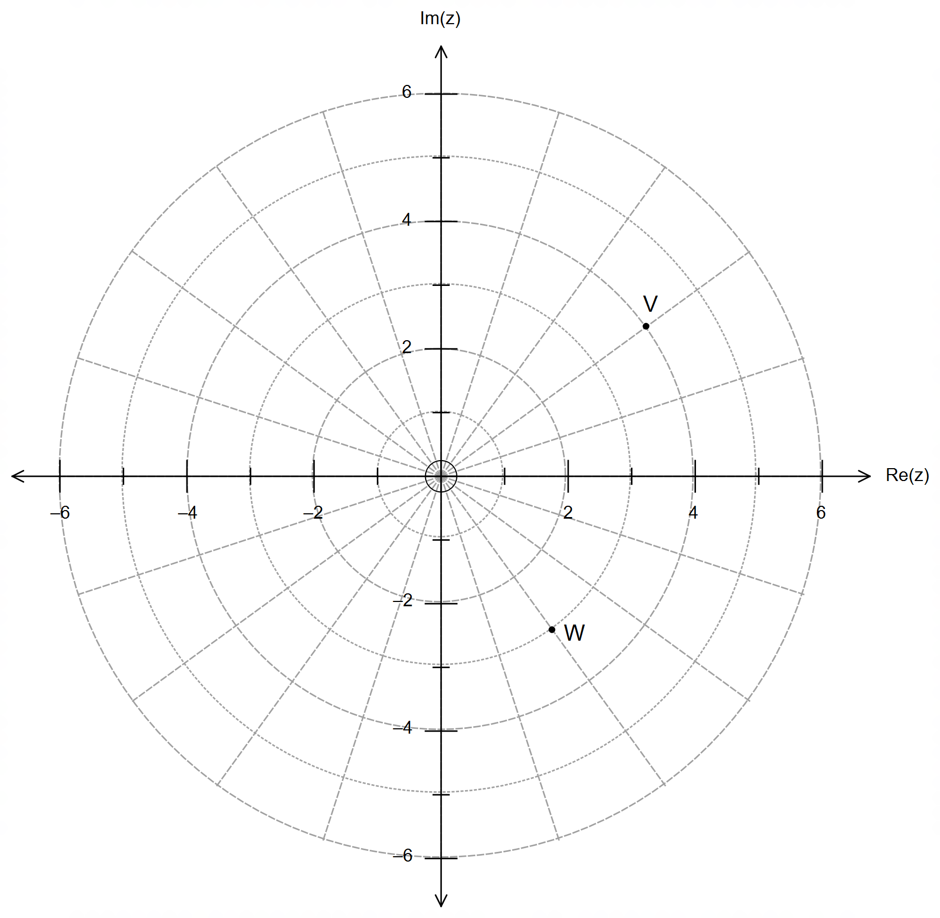

On the same grid above, mark the position of each of the following:

(i) $\frac{1}{2}\left(v×w\right)$ (2 marks)

(ii) $v^{-1}×8w$ (2 marks)

(iii) $\frac{v}{i^{3}}$ (2 marks)

Question 12 – Continued

(b) The diagram below shows the region represented by $\left|z-2-i\right|=4$

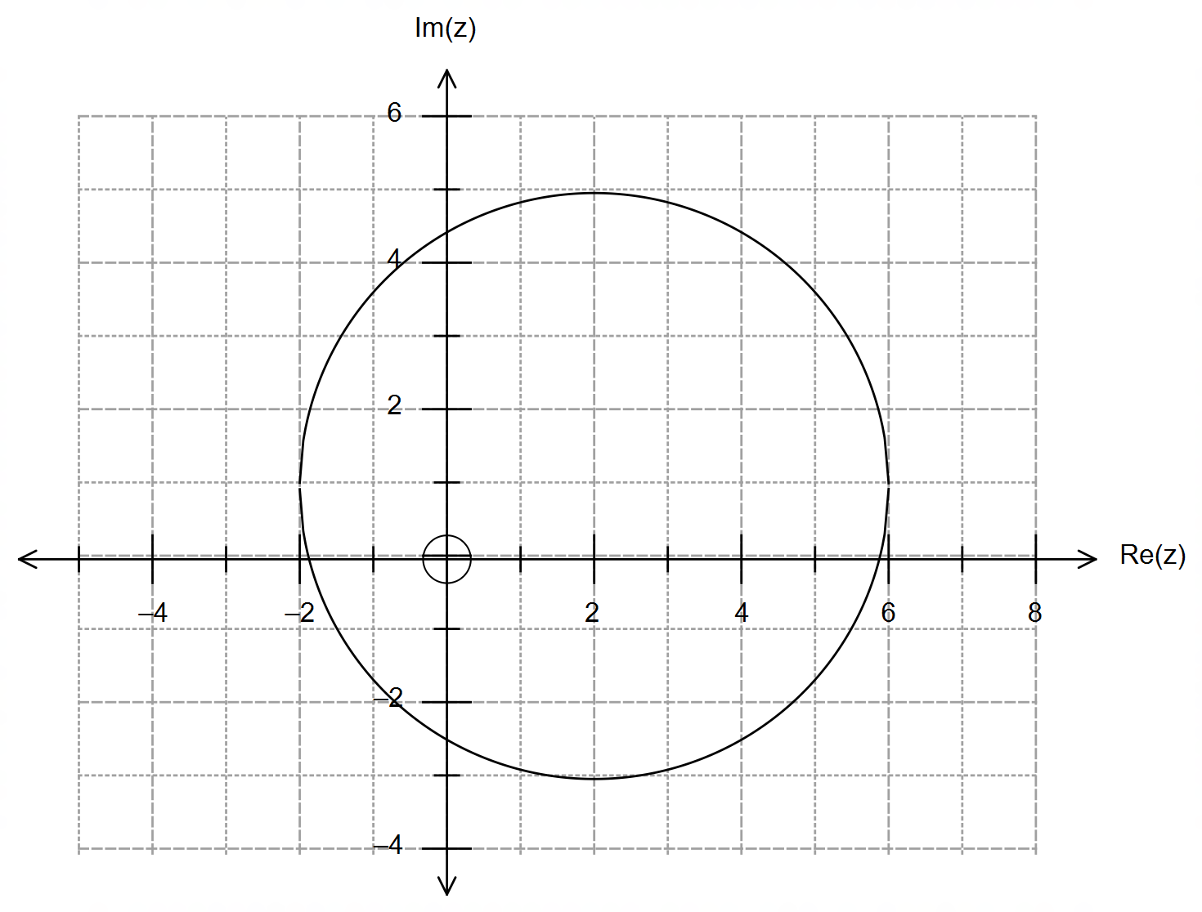

(i) Determine the minimum and maximum value of $\left|z\right|$. (2 marks)

(ii) Determine the value(s) of $arg(z)$ for when $Re\left(z\right)=4$. (4 marks)

Question 13 (12 marks)

A weather balloon is launched at $8:00$ am with a constant velocity of $25i-12j+2k$ metres per second, where $i,j$ and $k$ are unit vectors east, north and up respectively.
Fifteen minutes later, at $8:15$ am, ground computers detect a malfunction in the weather balloon and they launch instantaneously an intercepting rocket to try and destroy the weather balloon.
The rocket is launched from the position $6 400i-12 500j+300k$ metres relative to where the weather balloon was launched.

(a) Determine the speed of the weather balloon and the angle of its trajectory relative to level ground. Show working to justify your answers. (3 marks)

(b) Calculate the distance from the rocket to the weather balloon at $8:15$ am. (3 marks)

(Question 13 – Continued)

(c) The rocket is programmed to collide and destroy the weather balloon at $8:16$ am.
Determine the velocity of the rocket, and the height from level ground where the
collision occurs. (4 marks)

(d) If the speed of sound is $343$ m/s, determine the time elapsed for an observer at O,
the launching point of the weather balloon, to hear the collision after observing it. (2 marks)

Question 14 (9 marks)

Consider the complex number $z=\cos{θ}+i\sin{θ}$.

(a) Rationalise $\frac{1}{z}$ to show that $z^{-1}=\cos{θ}-i\sin{θ}$. (2 marks)

(b) It can be shown that $z^{n}=\cos\left(nθ\right)+i\sin\left(nθ\right)$ and $z^{-n}=\cos\left(nθ\right)-i\sin\left(nθ\right)$.
Use this information to show that $\sin\left(nθ\right)=\frac{z^{n} - z^{-n}}{2i}$ and $\cos\left(nθ\right)=\frac{z^{n} + z^{-n}}{2}$. (2 marks)

(Question 14 – Continued)

(c) Using your answers in (b), write an expression for $\cos\left(2θ\right)$ and $\sin\left(4θ\right)$ in terms of $z$. (2 marks)

(d) Using your answers in (c), determine an expression for $\cos{(2θ)}×\sin{(4θ)}$ in terms of
$\sin\left(6θ\right)$ and $\sin\left(2θ\right)$. Show working for full marks. (3 marks)

Question 15 (10 marks)

The graph below shows the function $f\left(x\right)=\cos{x}+1$ for the domain $0≤x≤2π$.
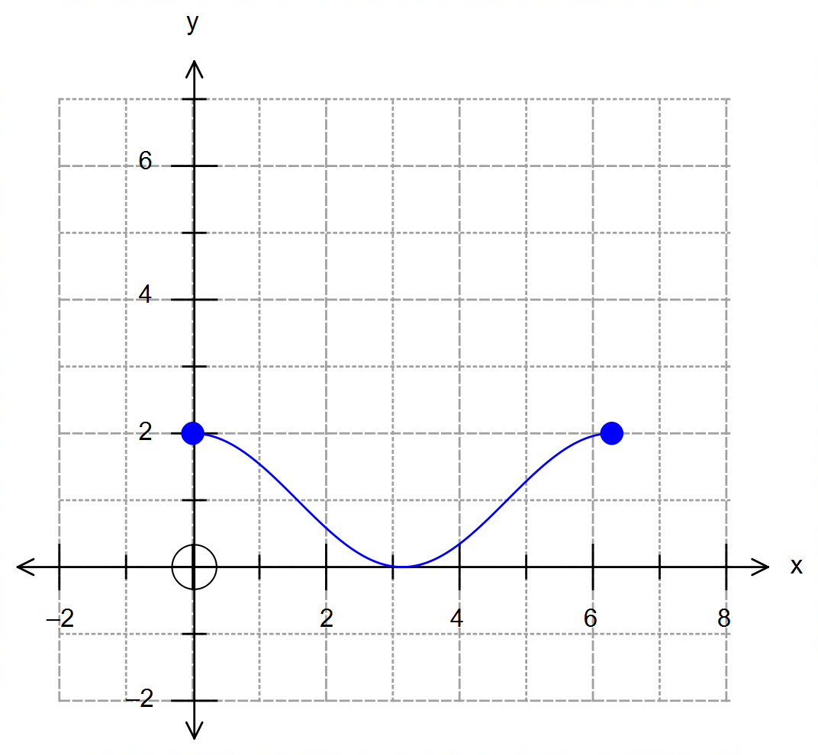

(a) Explain why the inverse function $f^{-1}\left(x\right)$ does not exist. (1 mark)

(b) The domain of $f\left(x\right)$ can be restricted to $k≤x≤2π$ so that $f^{-1}\left(x\right)$ exists.

(i) Determine the value of $k$ and then obtain an expression for $f^{-1}\left(x\right)$. (3 marks)

(ii) State the domain and range of $f^{-1}\left(x\right)$. (2 marks)

Question 15 – Continued

(c) Sketch on the same grid the function $f^{-1}\left(x\right)$ found in (b) (2 marks)

(d) The function $g\left(x\right)$ is such that $gf\left(x\right)=x+1$. Determine $g\left(x\right)$. (2 marks)

Question 16 (5 marks)

A particle moves along a path described by the equation $r=\cos\left(2θ\right)i+\tan{θ}j$, where $-\frac{π}{2}<θ<\frac{π}{2}$.

Determine the Cartesian equation of the path described by the particle. Show working for full marks.

(5 marks)

END OF QUESTIONS
Additional working space

Question number(s): ……………………

Additional working space

Question number(s): ……………………

Additional working space

Question number(s): ……………………

Additional working space

Question number(s): ……………………

